

**DATS 6313 Time Series Analysis and Modeling**

**Final Term Project**

**Liang Gao**

**Table of Content**

**Table of figures and tables**

The dataset I chose is a weather timeseries dataset. It is made up of many different quantities (e.g., temperature, atmospheric pressure, humidity) and were recorded every 10 minutes. The original data is from 1/1/2004 to 12/31/2020. I just chose the data from 1/1/2018 to 1/1/2021 (3-year) and changed it to *hourly data* (use the mean).

1. After preliminary clean, the shape of the dataset is **17545**\*22. The first column is date.
2. The target variable is the **Temperatrue**
3. The **20 numerical features** are:

p (mbar) - atmospheric pressure.

T (degC) - Temperature in Celsius.

Tpot (K) - Temperature in Kelvin

Tdew (degC) - Temperature in Celsius relative to humidity

rh (%) - Relative Humidity

VPmax (mbar) - Saturation vapor pressure饱和/最大蒸气压

VPact (mbar) - Vapor pressure蒸气压

VPdef (mbar) - Vapor pressure deficit(The difference between the actual vapor pressure and the saturated vapor pressure)实际水汽压与饱和水汽压之间的差值

sh (g/kg) - Specific humidit(The mass of water vapor per unit of wet air mass)单位湿空气质量中水蒸气的质量

H2OC (mmol/mol) - Water vapor concentration

rho (g/m**3) – Airtight

max. wv (m/s) - Maximum wind speed

wd (deg)- Wind direction in degrees

rain (mm) - The total rainfall depth during a given period, expressed in millimeters (mm).

raining (s) - total time of raining

SWDR (W/m²) - irradiance of shortwave solar radiation短波太阳辐射的辐照度

PAR (µmol/m²/s) - photosynthetically active radiation光合作用活性辐射

max. PAR (µmol/m²/s)

Tlog (degC)

CO2 (ppm)

**4. Abstract**

**5. Introduction**

**6.** Description of the dataset.

**The strength of trend for this data set is 94.37%**

**The strength of seasonality for this data set is 74.79%**

7. Stationarity

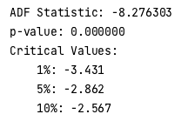 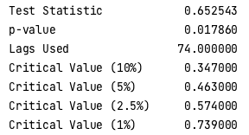

8.